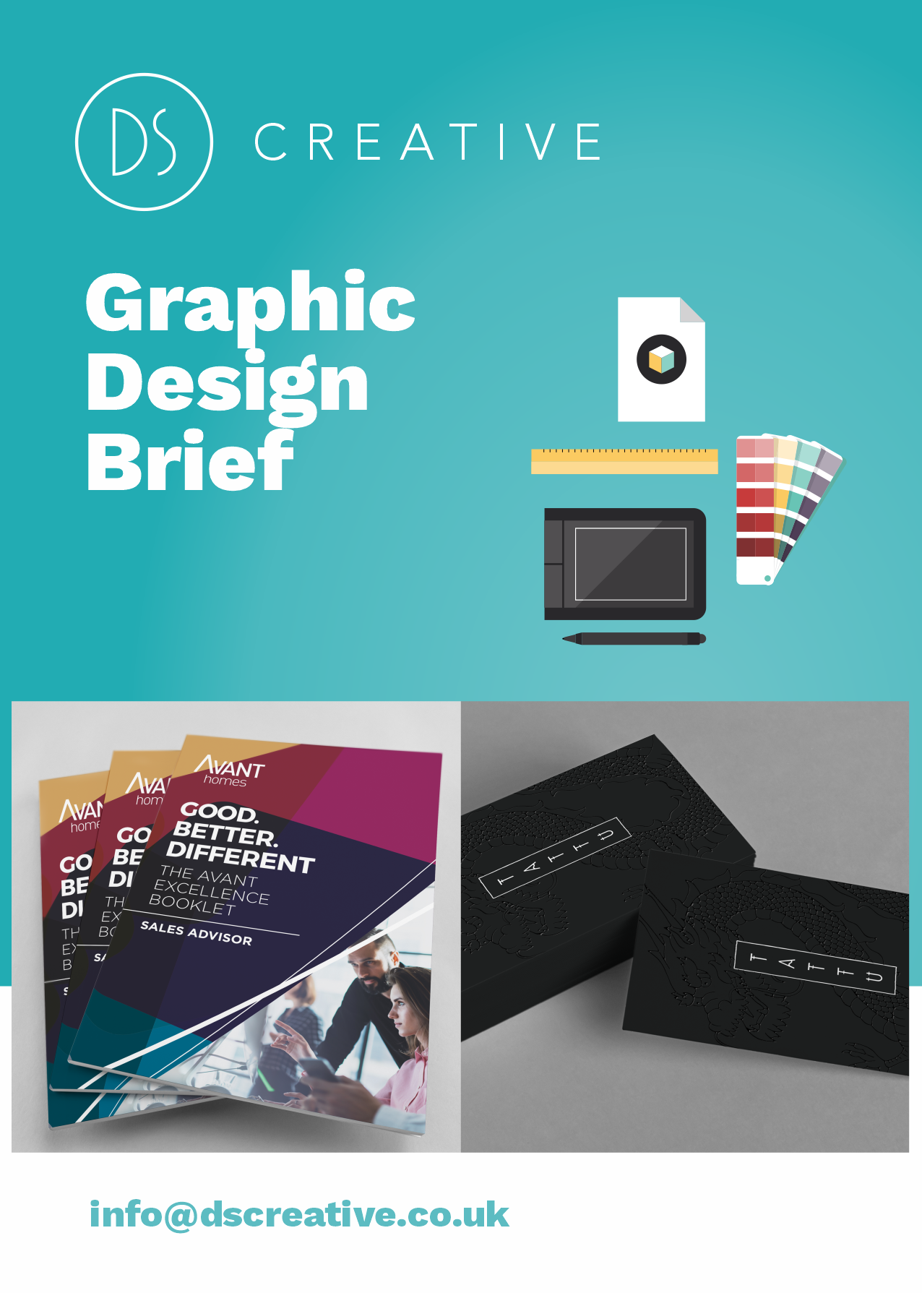

Graphic Design Brief

We create bespoke solutions for you and your brand. So the more information you can give us means a more accurate quotation and a design that fulfils your needs.

Once you have completed the brief and sent it to us, we’ll get down all our ideas then we’ll call you up or have a meeting to discuss the website proposal in full. We do this because we’ve found working closely with the customer creates the best websites.
If you want further information on what we can provide you or have any questions, please contact us on:

Tel: 0114 266 9000 or Email: info@dscreative.co.uk

A little bit about you

Name: Rebecca Thompson Company: Bramley Parish Council.

Email: clerkbramleypc@gmail.com. Phone:01709 544590.

Tell us about your company
Who are your customers? What are your main services? What’s your story?

We are Parish Council, we provide community services and support throughout the parish.

What do you need us to design?
What product(s) would you like us to design? What sizes do you require? (e.g. 14 16pp brochure, A0 poster etc.)

A small welcome booklet for new residents.

info@dscreative.co.uk DS Graphic Design Brief 2

Design Goals/Aims: How will the design help you and your business?
Why do you want the design? What should the design achieve? What are your goals? e.g. increase product sales, promote an event, attract more customers to your business etc.

To promote what the Council do and also give useful details on the area.

What is the purpose of the design? Do you have any key messages/call-to- actions we should include?

Is there a specific action you want the audience to complete after seeing the design (e.g. call your team, look at your website)? What is the most important text/idea the design should communicate?

Clear, simplistic but professional.

Where will the design be used?
Do you have a specific place the design will be used/placed (e.g. a event, in a specific local magazine, on social media etc.)?

It will be given to new residents on two new residential developments.

How do you want your design to look?
Do you have any ideas about the style of your design? Do you have any company guidelines we should be following (e.g. logo, brand colours etc.)?

We would like our logo to be present.

info@dscreative.co.uk DS Graphic Design Brief 3

Who are your target audience? Who is the design aimed at?
Do you have a specific audience for your design? Who are your typical customers?
New residents to the Parish.

Who are your competitors?
Tell us the companies you are competing against. What can we do to make your design stand out?

n/a

Design examples you like
What design examples do you like? What styles would you like us to use?

Design examples/styles you dislike
What design examples don you dislike? What styles/colours would you like us to avoid?

info@dscreative.co.uk DS Graphic Design Brief 4

Do you require stock photography/any imagery from us?
Will you be supplying your own photography or should we advise on this?

n/a

Budget: Do you have a budget we should adhere to?
This is optional and it won’t affect the price we quote, but it will give us an idea if the design you are requesting is realistic for the budget you have. It can also help us suggest design options that will best fit your budget.

What’s your timescale?
We understand that everyone has different needs and you may require a fast turnaround.

Preferably within the next 7 days.

Anything else?
Do you have any other requirements that haven’t been addressed in the above answers?

info@dscreative.co.uk DS Graphic Design Brief 5


Now that you’ve completed the form,
please email it to: info@dscreative.co.uk
We will then be in touch with a proposal as soon as possible.

info@dscreative.co.uk DS Graphic Design Brief 6

