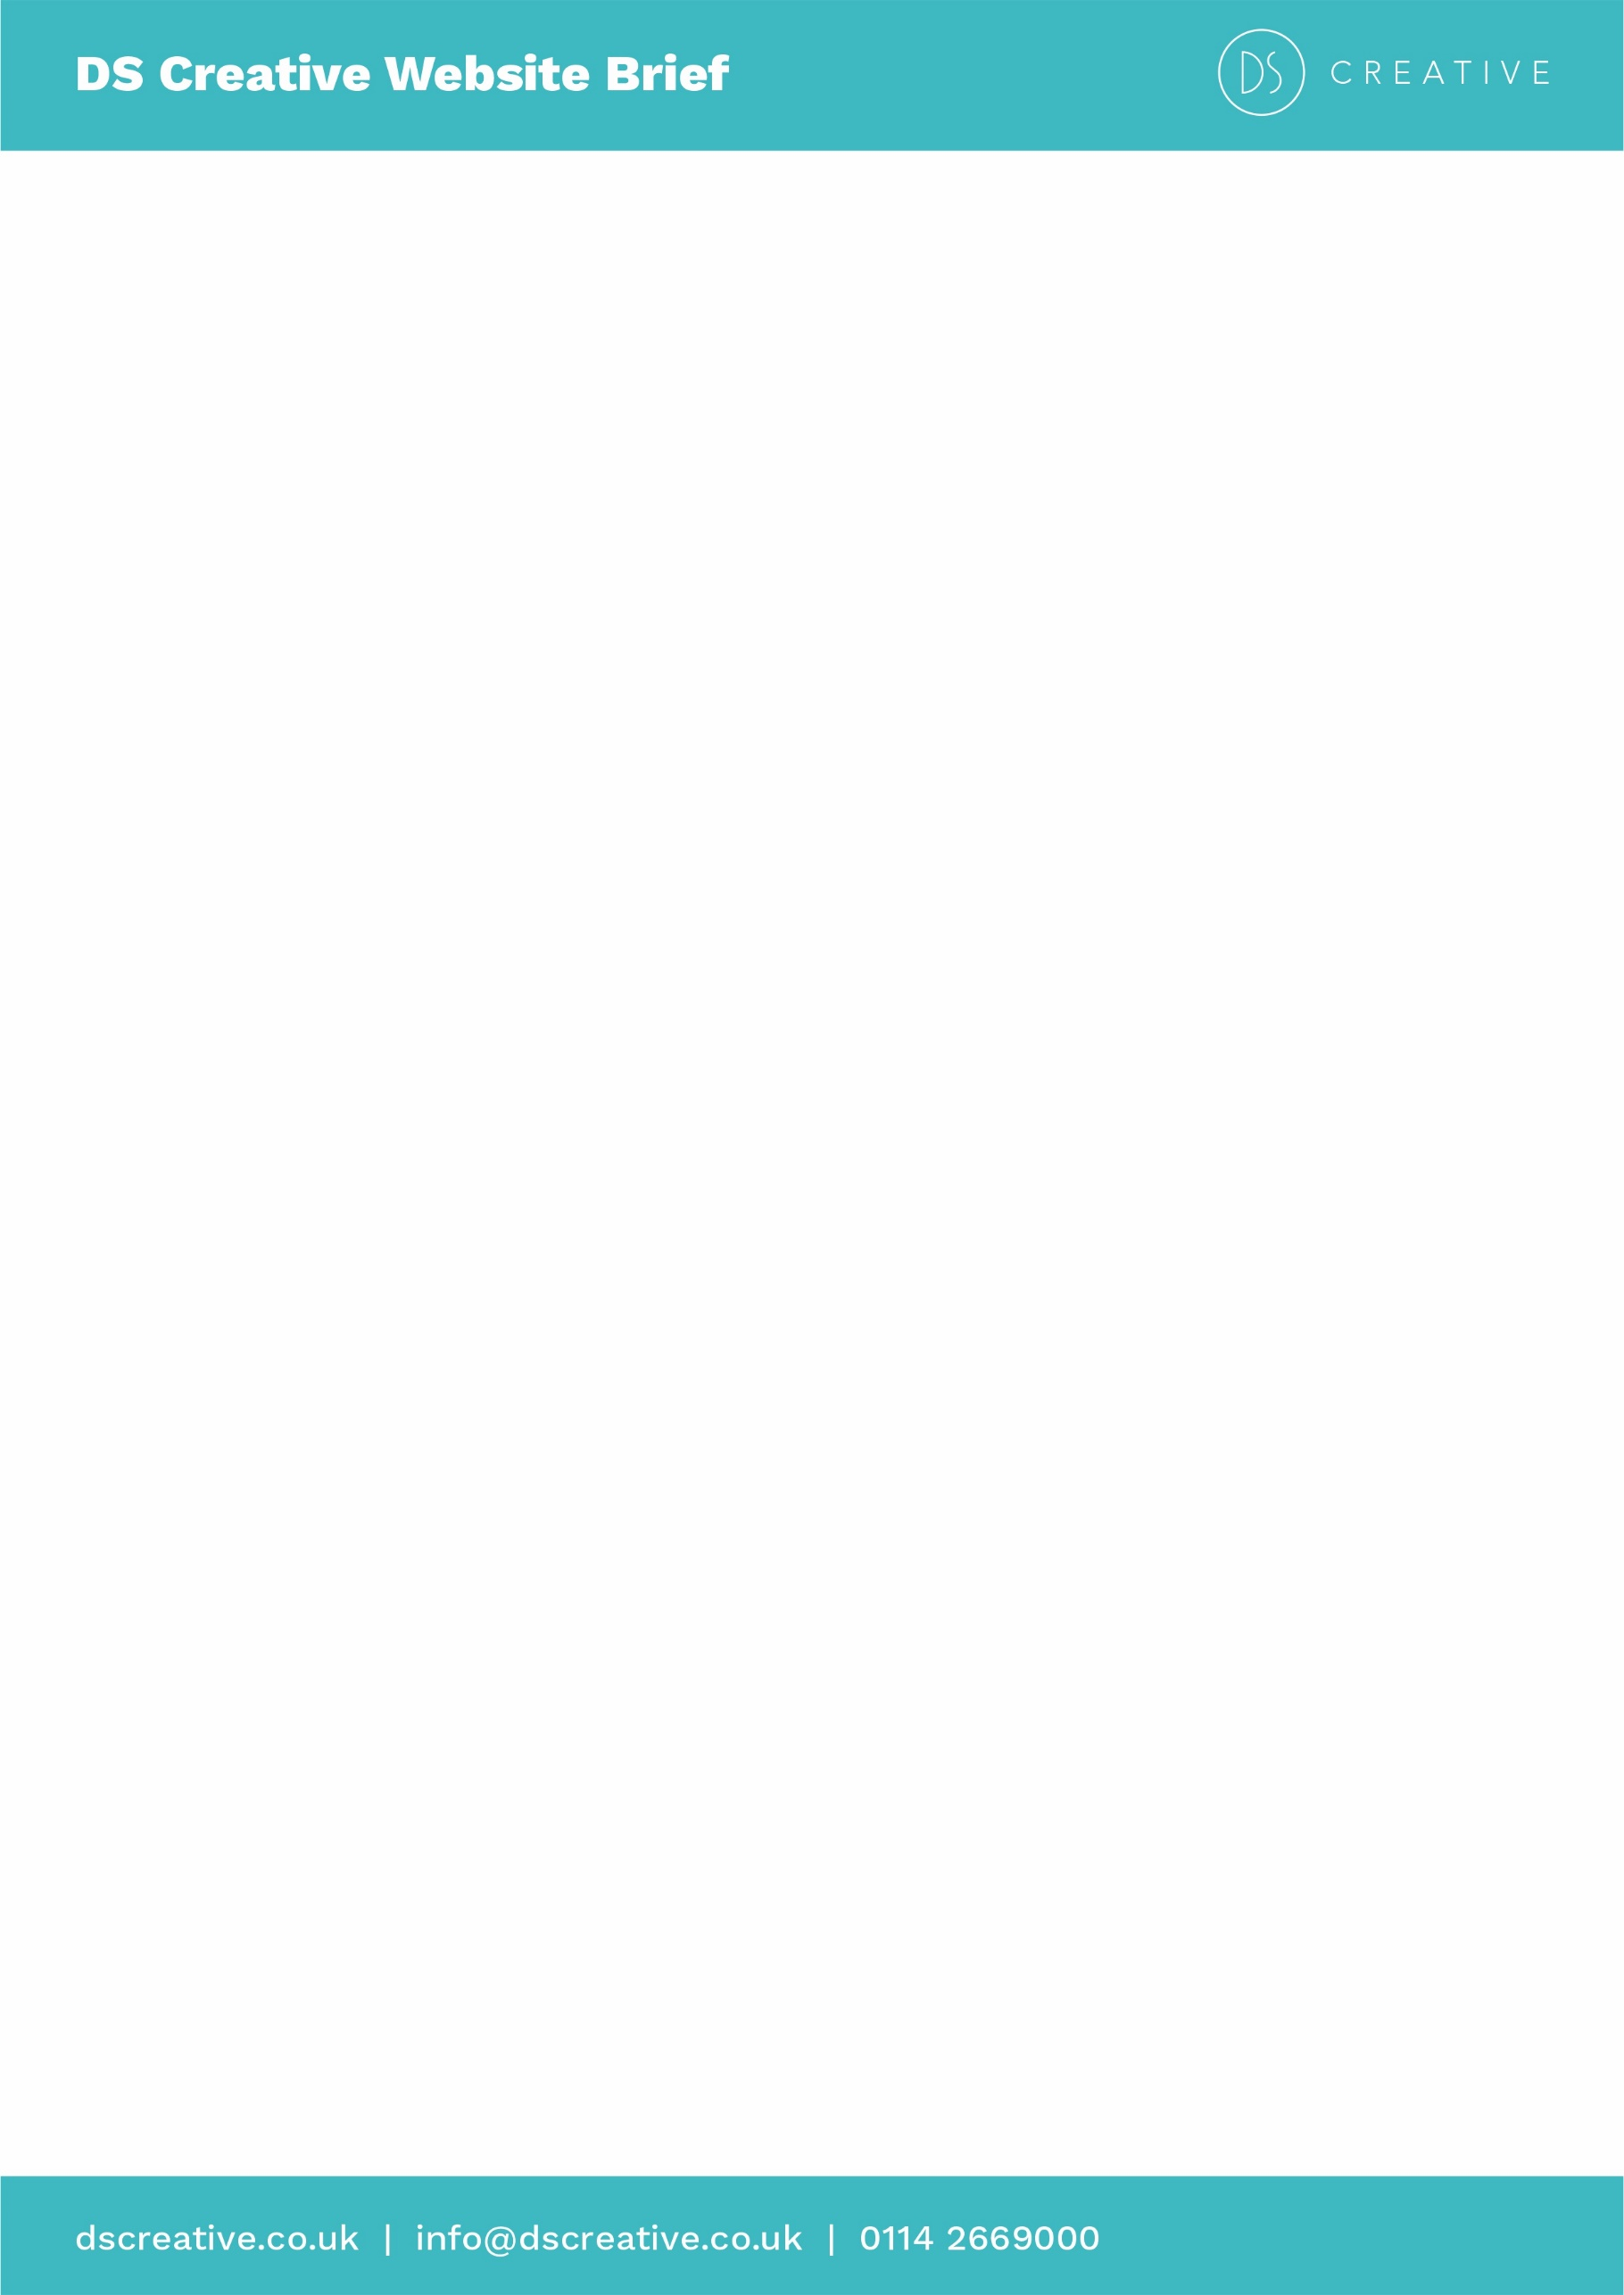
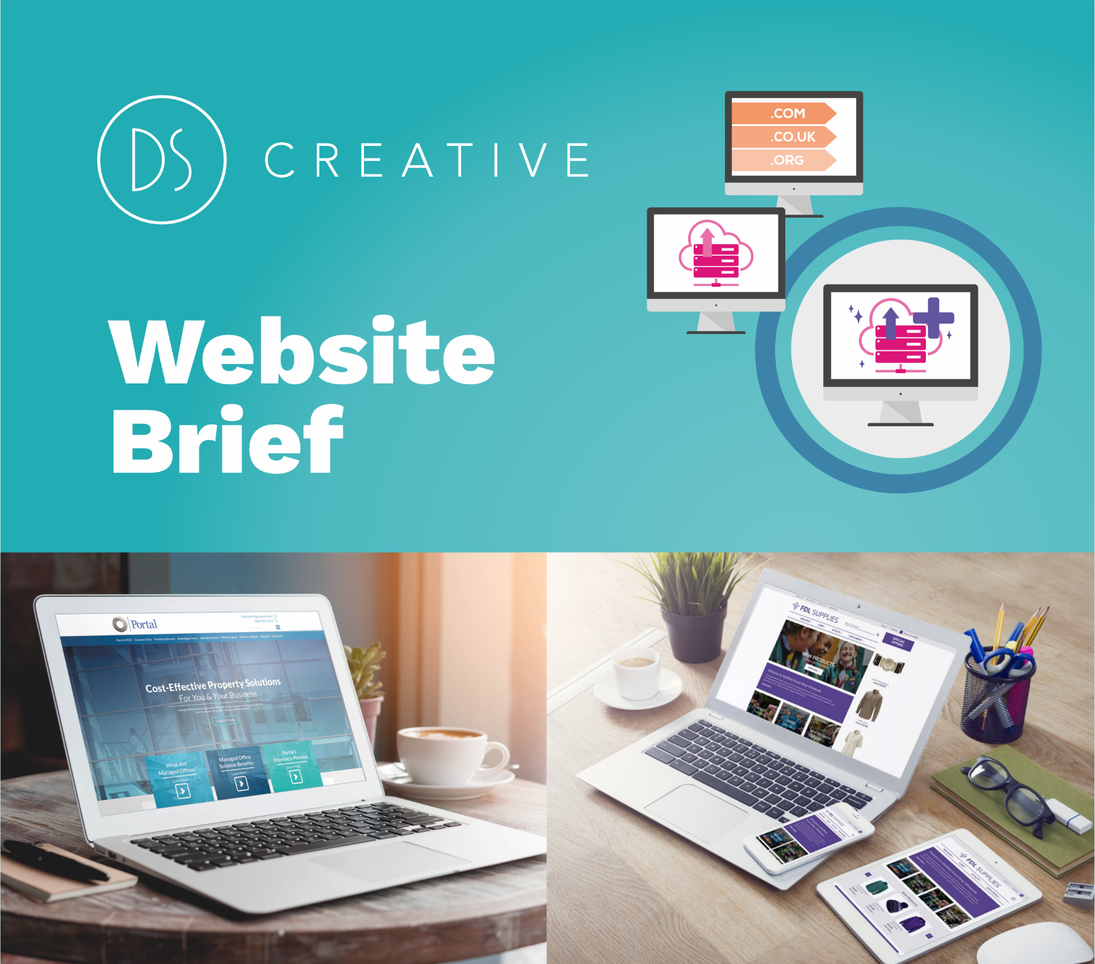

Here at DS we create bespoke solutions for you and your brand. So the more information you can give us means a more accurate quotation and a website that fulfils your needs.
Once you have completed the brief and sent it to us, we’ll get down all our ideas then we’ll call you up or have a meeting to discuss the website proposal in full. We do this because we’ve found working closely with the customer creates the best websites.
If you want further information on what we can provide you or have any questions, please contact us on:
Tel: 0114 266 9000
or Email: info@dscreative.co.uk

A little bit about you
Name: Paul Gate | Company: Pneumatic & Hydraulic Couplings Ltd
Email: paul@phcltd.net | Phone: 0114 2442704

1) Tell us about your company
Who are your customers? What are your main services? What’s your story?
Click or tap here to enter text.

2) Do you have a website at the moment?
If so, what is your current web address? What aspects of your current site work well and which don’t?
No

3) How will your website help you and your business?
Why do you want a website? What should your website achieve?
It will hopefully promote our company and the services we offer.
We are liking to have a e-commerce option along with ebay integration.
4) How do you want your website to look?
Do you have any ideas about the style of your website? Do you have any company guidelines we should be following (e.g. logo, brand colours etc.)?
I will leave that up to you, I don’t have any preferences at the moment.

5) Tell us what websites you think are great
What websites have features you want to have? What websites really catch your eye? Are there any websites that you want your new website to look like (and if so what do you like about them)?
Click or tap here to enter text.

6) Who are your competitors?
Tell us the companies you are competing against. What can we do to make your website stand out?
Click or tap here to enter text.
7) What should your website be called?
What domain name do you want? If you already own one what is it called? (A domain name is just your web address, e.g. www.google.com
www.phconline.co.uk
8) What pages/headings do you need?
What pages does your current site need? E.g. Home, About Us, Services, Gallery, Contact Us, etc.
Please list
Home, About Us, Services, Gallery, Contact Us

9) Roughly how many pages do you think your website needs?
Click inside the square to select how many pages you estimate you need.
☐ 1 - 5 | ☒ 6 - 10
☐ 11 - 24 |  | ☐ 25 - 50
☐ 51 - 100 |  | ☐ 100+

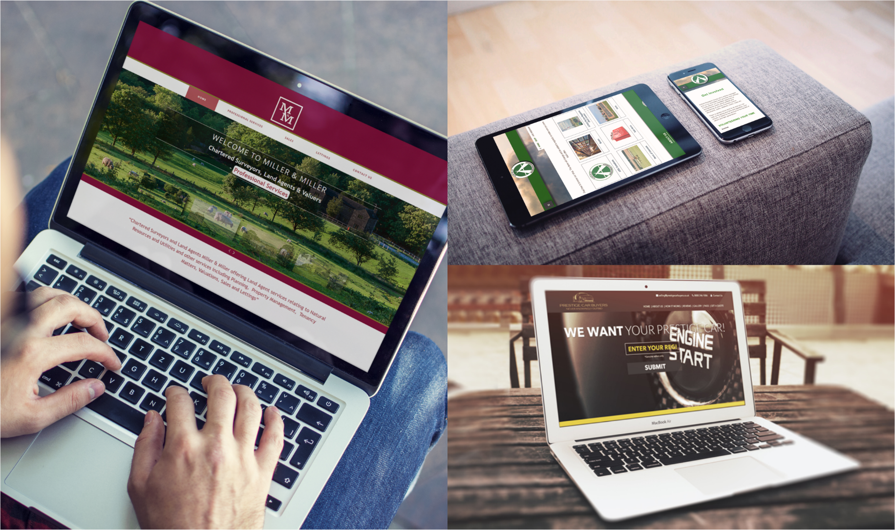

10) Do you want any of these features?
These features can make the difference between a website that stands out and one that does not. To get any of these features clarified just let us know. Click inside the square to show your interest.
☐ | Content Management System (CMS) - A content management system or CMS is software that enables you to create, edit, organise, and publish your own content, without the need for a web developer. Wordpress is our recommended system for this which has a 60% share in the CMS market.
☒ | E-Commerce (CMS) - Sell your products online with an E-Commerce website. We generally use Prestashop or WooCommerce to provide this service.
☐ | Social Media Integration - Legitimise your website, have all the avenues open for people to view, like and finally purchase your products.
☒ | Search Engine Optimisation (SEO) - We offer an on-page SEO package to get you appearing in relevant Google searches.
☐ | Blog - Let your customers know your latest news, upcoming events or just what you are thinking today.
☐ | Newsletter Subscription - Start creating a community and send emails to your potential customers. Let them know important news, offers and any information on how great your company is. We generally integrate with Mailchimp.com to provide this service.
☐ | Events Booking - Have an events system where you can easily create new free or paid events where users can register onto them.
☒ | Google Analytics - See how your website is performing, where users are coming from and details specs of your website.
☒ | Google Ads - Advertise your new website to the world with attention grabbing ads.
☐ | Google Maps - We can embed Google Maps into your website and provide and this can be linked to your google account to add new locations to the map, along with photos and descriptions.
☐ | Contact Form - A contact form is basically a set of questions filled out on the webpage by your visitor that is automatically sent to your email when it is filled out.
☐ | Live Chat - Talk to customers whilst they are using your website. Make sure you do not lose a single sale.
☒ | Stock Photography Images - Stock images are a great resource to get high quality and cheap photos that you can use on your website for various purposes.
☐ | Image Gallery/Slideshow & Video - Showcase your website using an image gallery, slideshow and video.
☒ | Security Package - Minimise the risk against website security breaches with an annual security package. Package includes: Securing website | Monitoring of and speedy installation of critical security fixes | Free updating of core software (e.g., Joomla, WordPress, Prestashop) | Free updates to websites add-ons and plug-ins
☒ | SSL Certificate - SSL certificates are a simple but essential way to keep sensitive information safe while giving customers the confidence they need to complete any transaction. Google has announced that they prefer secured sites, giving anyone who protects their website data a boost in search engine rankings as well as displaying the secure padlock icon.
11) Are there any other features that you want on your website
Please note that any other specifications/requirements required for your website that you have not mentioned will not be included in your quote. It is important to make sure we understand these requirements at this stage.
E-commerce integration with our largest supplier and integration with ebay.

12) What’s your timescale?
We understand that everyone has different needs, and you may need that extra boost to your business sooner. That’s why we offer the Website FastTrack where we’ll speed up the delivery of the website. Working with you we’ll be able to complete the website within your specific deadline.
☐ Less 4 Weeks - Super FastTrack | ☐ 4-6 Weeks - FastTrack
☐ 6 - 8 Weeks | ☒ 8 Weeks +

13) What’s your budget?
This is optional and it won’t affect the price we quote, but it will give us an idea if the site you are requesting is realistic for the budget you have.
☐ £500 - £1000 | ☐ £1000 - £3000
☐ £3000 - £5000 | ☐ £5000 +

Now that you have completed the form, please email it to: info@dscreative.co.uk
We will then be in touch with a proposal as soon as possible.

